Login to PLYSSQL147P.

Open SQL Server Management Studio.

Select the database **Allergan.**

**Generating History Data:**

1. Run the below query.

This will display the latest Data Month name for Sweden. Here, latest month is M112012.

select * from Allergan_Load_Details where country = 'SE'

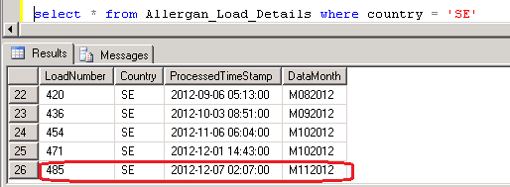

2. Run the Below query with the Latest Data Month Load Number.

This will display the backup data of M112012 Which was loaded in last production run.

select * from Allergan_Output_History where loadNumber = 485

3. Run the Below SP which will load the latest production period data from Production

Server (PLYSSQL147P) to Development Server (PLYSSQL146D)

EXEC dbo.usp_Populate_History_Data 'SE','MmmYYYY'

where mm = Current Production Month Number (01, 02, ... 11,12)

and YYYY = Current Production Year.

4. Run the below query to check whether the latest production period data loaded or not

select * from Allergan_Load_Details where country = 'SE'.

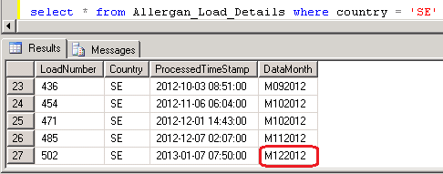

5. Run the **MergePacks.exe** from D:\FTP\MergePacks tool\

6. Click on Build Report

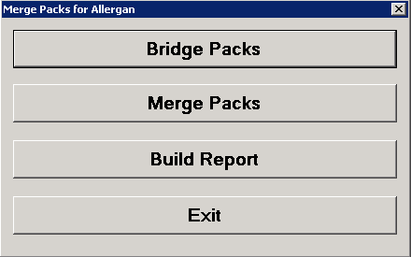

7. Select Country = SE and Previous Build = Previous Month. Click OK

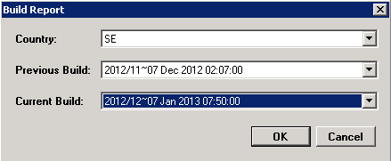

8. After successful run Below window will appear and the History Correction Report will generate at D:\FTP\MergePacks tool\Reports

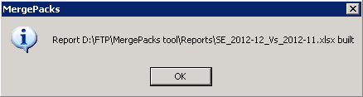

9. Copy the report file and backup at D:\FTP\MergePacks tool\Reports\YYYY\YYYYMM

where MM = Current Production Month Number (01, 02, ... 11,12)

and YYYY = Current Production Year.

10. Download the history excel file into Local and rename

History_Corrections_Sweden_monYYYY.xlsx

where mon = Current Production Month Name

and YYYY = Current Production Year.

This file should mail to Allergan with delivery mail.

**Input Flat File vs Output Data:**

1. Login to 162.44.12.72 server.

2. Copy the input flat file **Allergan.csv** from production server (PLYSSQL147P) D:\Allergan\Archive\Sweden and paste at the location \\162.44.12.72\d$\Allergen\Sweden\YYYYMM

where MM = Current Production Month Number (01, 02, ... 11,12)

and YYYY = Current Production Year.

3. Copy the output file **Sweden_MMYYYY.csv** from production server (PLYSSQL147P) D:\FTP\Allergan_Production_Output\Renamed_Outputs and paste at the location \\162.44.12.72\d$\Allergen\Sweden\YYYYMM

where MM = Current Production Month Number (01, 02, ... 11,12)

and YYYY = Current Production Year.

4. Create the QC File QA_Sweden_YYYYMM.txt

where MM = Current Production Month Number (01, 02, ... 11,12)

and YYYY = Current Production Year.

5. Open all the 3 files **Allergan.csv, Sweden_MMYYYY.csv** and **QA_Sweden_YYYYMM.txt**  with TextPad

6. Copy any single line from input flat file **Allergan.csv** and paste into **QA_Sweden_YYYYMM.txt.**

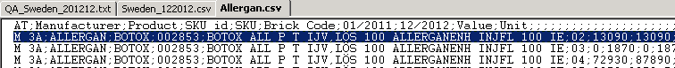

7. In the output **Sweden_MMYYYY.csv** select 3 measures records where SKU (PackId), Brick Code matches with the selected Input file record.

For example : in the below record

SKU = 002853 Brick Code = 02

Additional Checking

Manufacturer = Allergan AT/Sublevel = M 3A

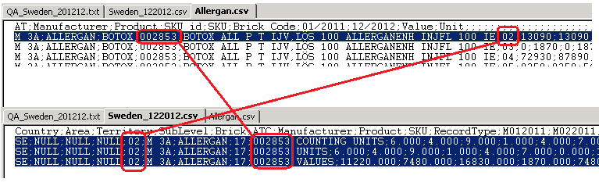

8. Match the Sales Values of input vs output.

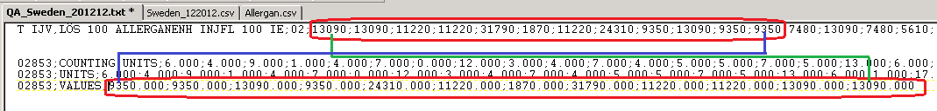

9. Match the Units of input vs output.

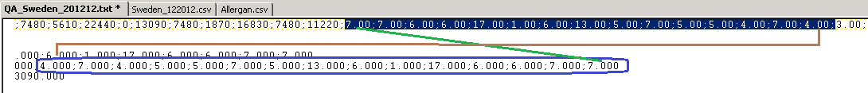

10. Select at least 8 records and do the same.

**Summary File Checking**

1. Open the Summary File **SwedenSummary.txt** from Production Server (PLYSSQL147P) from the location D:\FTP\Allergan_Production_Output with TextPad

2. Check the ratio with the Previous month vs Current month.

3. Check if the ratio decrease of previous vs current for any measure, rest 2 will decrease also

SE;M 3A;HAMELN PHARMA;139;COUNTING UNITS;**246.000;209.000**

SE;M 3A;HAMELN PHARMA;139;UNITS;**246.000;209.000**

SE;M 3A;HAMELN PHARMA;139;VALUES;**137703.000;109785.000**

4. Check if the ratio increase of previous vs current for any measure, rest 2 will increase also

SE;M 3A;ORGANON;24;COUNTING UNITS;**666.000;1492.000**

SE;M 3A;ORGANON;24;UNITS;**666.000;1492.000**

SE;M 3A;ORGANON;24;VALUES;**258399.000;591145.000**